

Application for driving test

simulation

Student: Andreea Marin

Teacher: Aron Baka-Balint

**Contents**

1. Short description of the project
2. UCs presented in details
3. Screenshots
4. Solution presentation
5. Conclusion
6. Further improvements

1. **Short description of the project**

The project develops an application for driving test simulation.

The application provides the user with random quizzes, each quiz containing 26 questions. At the end of the quiz a message is displayed. The message can be either ‘Picat!’ when the time expires (30 min) or when the number of allowed errors is exceeded (no more than 4 wrong answers) or ‘Reusit!’ if the number of correct answers is equal or greater than 22. After finishing a quiz, the user has two options: to take another quiz or to exit the application.

1. **UCs presented in details**

After pressing the ‘run’ button the application starts and a window will appear on the screen. It contains an image and a button – ‘start’ which must be pressed in order to start the quiz.

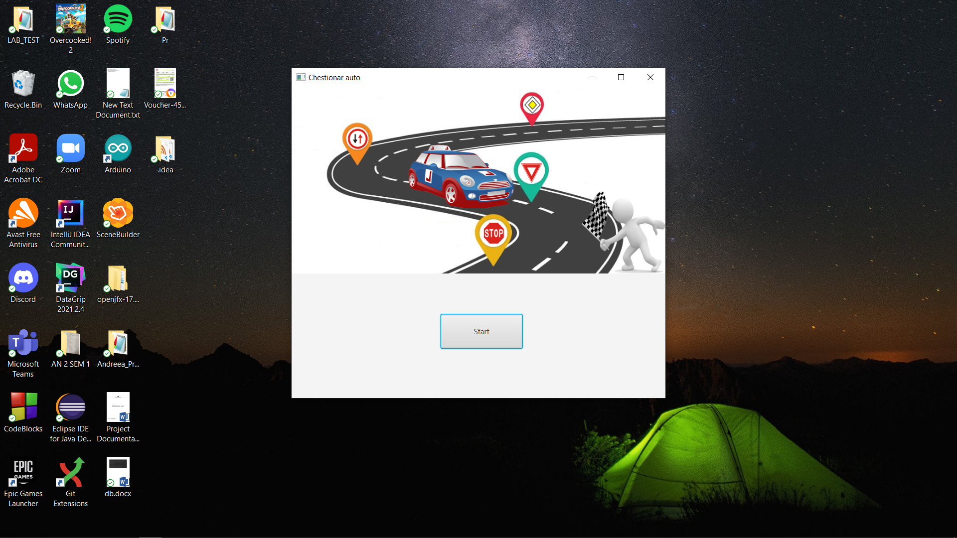

After pressing the ‘start’ button, the quiz will start and the following things will appear on the window screen. The title of the application will change from ‘Chestionar auto’ to ‘Chestionar nr’ where nr represents the ID of the quiz. At the top of the window the number of correct and wrong answers will be displayed and updated as the user answers the questions. The middle of the window will display the question and the 3 answers. The user selects the answers by clicking on the empty square placed before every answer and, after clicking, a tick will appear inside the square.

The ‘urmator’ button placed at the bottom of the window is used in order to move to the next question. At the left bottom corner the user can see the timer which counts down from 30 minutes.

The window also contains a scrollPane situated in the right side of the screen which shows the number of the current question.

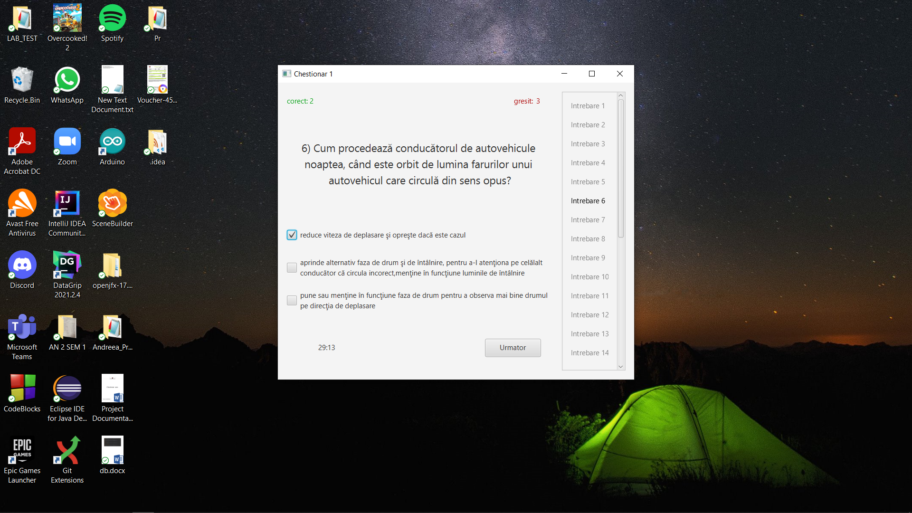

The quiz ends either after answering all 26 questions, or after answering wrongly to more than 4 questions, or after the time is over. The user passes the quiz if more than 22 questions were correctly answered. The quiz is failed if the user has more than 4 wrong answers or the time is over.

At the end of the quiz, the user has 2 possibilities: either to press the ‘Reia’ button which generates another quiz, or to press the ‘Iesire’ button which exits the application.

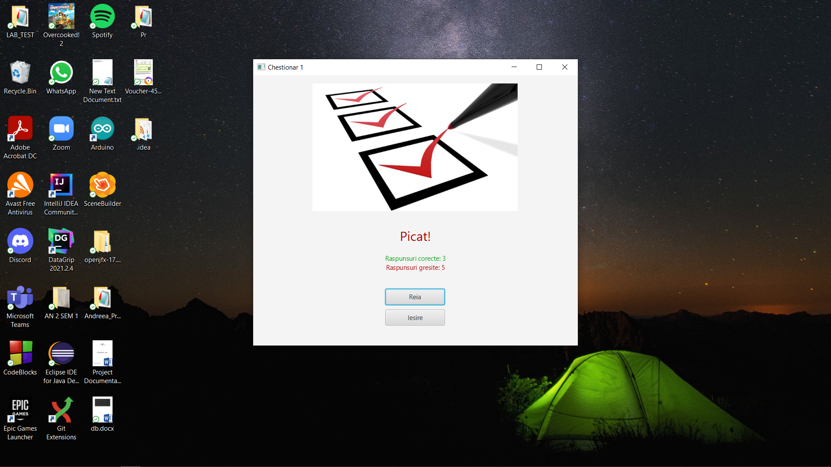

1. **Solution presentation**

* **Architecture**

For this project I used an MVC architecture. It consists of three parts: **Model, View and Controller**.

The Model part (the backend) directly manages the data, logic and rules of the application, the View (the frontend) part is used to display the information from the model to the user and the Controller part is used to control the data flow into a model object and updates the view whenever data changes.

* **Data structures used**

When it comes to data structures I used List and Map. I used two lists of type string, one for storing the correct answers and one for storing the wrong answers and another list of type question for storing the questions randomly chosen from the file Question.txt. Map is used so that the questions won’t appear more than once in the same quiz.

* **Test**

For this project, I also created two test classes: one for questions and one for the quiz. The test class for question tests if the correct and wrong answers are added correctly. The test class for quiz tests if the number of answers is three and if the question appears in the question list or not.

1. **Conclusion**

As a conclusion, the application helps users prepare for their driving test exam and the advantage of taking another quiz without exiting the application allows them to easily remember the answers, understand and memorize them.

1. **Further improvements**

A very useful improvement that can be done would be to introduce the option of navigating through questions. This aspect would allow the user to skip the questions he is not sure of and come back to them after answering the questions he knows the answer to.